**INFORMATION SYSTEMS COURSEWORK**

BY :

SOHAIL AHMED ZAMAN

ID 38879972

**FUNCTIONAL REQUIREMENTS**

* The functional requirements for the project are broken up into 2 parts – Process oriented requirements and information-oriented requirements.

***Process Oriented:***

* The process-oriented functional requirement defines what a system should do and perform. The process Oriented requirements for the project are :

1. The website must allow the user to store the user’s favorite collection of cars.
2. The system should allow the user to view a table of records about the cars available.
3. The system should allow the user to populate the table by adding new content.
4. The system should allow the user to delete specific content from the table
5. The system should allow the users to edit or update the current contents of the table

***INFORMATION ORIENTED:***

The information-oriented functional requirements define what information the system should hold in this case

1. The system should store an inventory of the cars present on the website
2. The system should store the user details and past orders

**NON FUNCTIONAL REQUIREMENTS**

The non-functional requirements define the characteristics the system should have

1. ***Operation:*** the system should be able to work on any web browser and should integrate with the existing inventory system
2. ***Performance:*** the system should be fast and reliable
3. ***Security:*** only the users can see their details

**USE CASE ANALYSIS**

Use Case Name :

***Actor:*** user

**Description:** Describes a user who searches and browses for a rental car on the website

**Trigger:** user uses the website to search and browse cars

***Preconditions:***

The website is available on the web

The database is online and working

***Normal Course:***

1.1) the website displays the home page

1.2) the user clicks on the sign-in or login-in page

1.3) the user clicks on the view function

1.4) searches for a specific car

1.5)The website matches a car with the search request

1.6) the user selects the car desired

1.7) the user rents the car

***Postcondition:***

***Exceptions:***

Search requests return no results

1) the website displays a message that no results were found

2) the website asks the user to try again

***Summary of use case:***

|  |  |  |  |
| --- | --- | --- | --- |
| INPUT | Source | OUTPUT | DESTINATION |
| Signup | User | A new User account created | Signupdb |
| Login | User | User enters website | Signupdb |
| Add | User | New data is created | Carsdb |
| Update | User | Data is updated | Carsdb |

**DATA FLOW DIAGRAM**

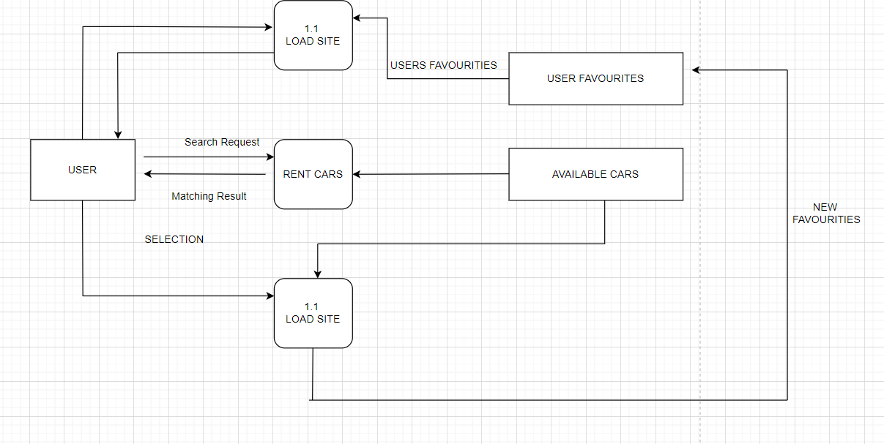

**Entity-Relationship-Diagram**

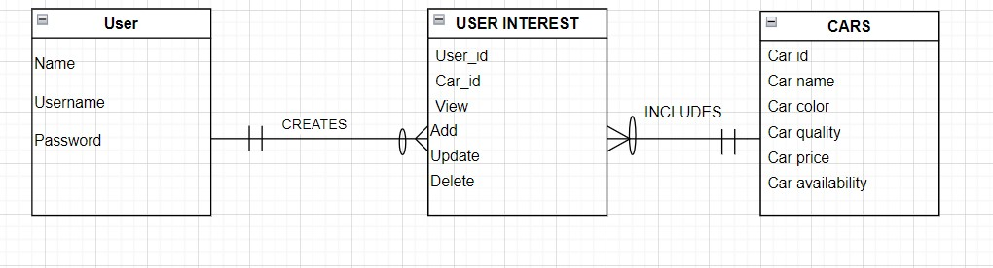

**STRUCTURE DIAGRAM**

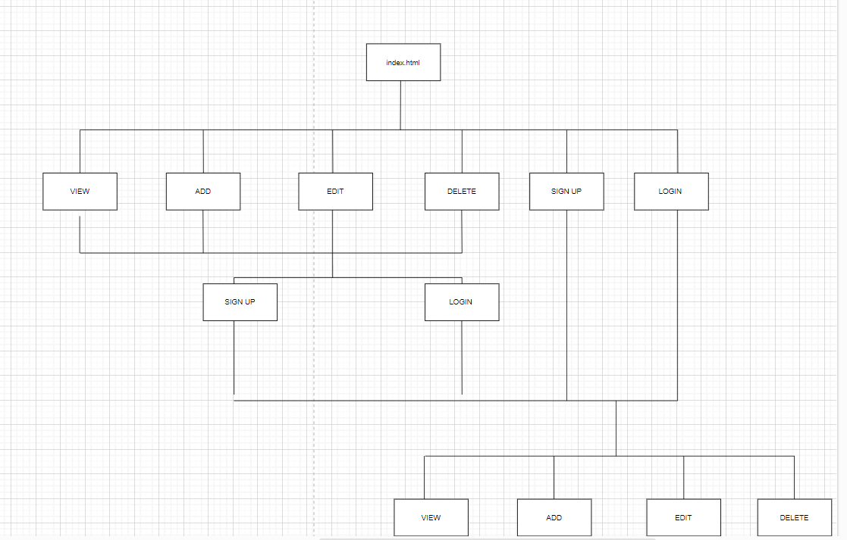

* The index.htm main page contains 6 links as shown in the diagram
* If the user is not registered and clicks on any of these links it opens the signup or login page.
* After the user signs up or logins in they will be directed to another page with the main four links as shown and the user then can view, add, edit, and delete the contents of the database table in the website

**SUMMARY**

This report summarizes all the functional, no functional, use case analysis, data flow, and entity relations diagrams along with the structure of the website.

The functional requirements for the project are divided into 2 parts: process-oriented and information oriented. The process-oriented requirements include features like allowing the users to store their favorite collection of cars, and view those collections along with having the feature to add, delete and update the collection and view the trends of the collection. Information-oriented requirements include storing information about the cars available and rented on the website.

The non-functional requirements are requirements or features that specify the characteristics the system should have. These include the ability to work on any web browser, being fast and reliable, and storing the information entered by users securely

The use case analysis describes the system from the user’s point of interaction. it specifies all the steps that are involved in the user searching for cars, adding, deleting, updating viewing, etc. The analysis also has triggers, preconditions, normal conditions, post-conditions, and exceptions that might occur. After the use case analysis, a small report is written.

The data flow diagram illustrates the flow of data that takes place inside the system. It illustrates how the data is moved from the user interface (UI) into the database and vice versa.

The entity-relation diagram provides a visual representation of the entities and their relations within the system. It demonstrates the organization of the data inside the system

The structure diagram represents the website will be laid out including how the system will work from an abstract point of view. It details how each page is connected and how the whole is implemented